## Use Case 1

## Name: Account Information Change

Changing account information:

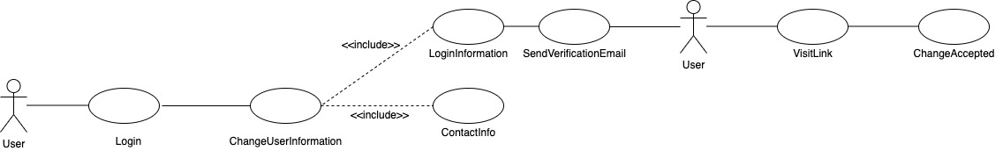

Participating actor: Any User

Entry condition:

* User has access to a supported web browser and connection to the server.

Exit condition:

* User has changed login or contact information

Event flow:

1. User logs in to their account.
2. User requests chang(es) to their information

* If changing contact information, change is accepted without any other steps
* If changing Login Information

1. Send verification of change email to the User
2. User visits link in verification email
3. Information is updated

## 

## Use Case 2

## Name: Place Order

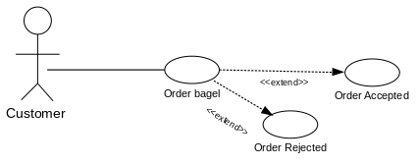

Participating actor: Customer

Entry condition:

• Customer is on the website

• Customer would like to place an order

Exit condition:

• Customer receives confirmation of order

Event flow:

1. Customer selects items to be ordered and time to pickup

2. Website displays order total

3. Customer approves withdrawal of funds

4. Website sends order to Server

5. Server accepts order or rejects order.

6. Website displays order result to Customer

## 

## Use Case 3

## Name: Marking order as prepared

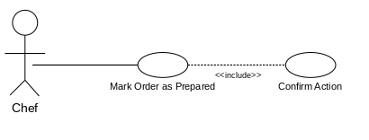

Participating actor: Chef

Entry condition:

• Chef has finished preparing an active order

• Chef is on the Website

Exit condition:

• Chef receives confirmation that order has been updated

Event flow:

1. Chef selects completed order

2. Website sends update request to Server

3. Server confirms update

4. Website displays updated order list

## 

## Use Case 4

## Name: Marking order as picked up

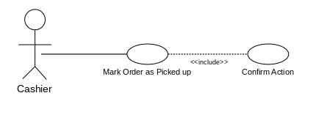

Participating actor: Cashier

Entry condition:

• Cashier has given order to Customer

• Cashier is on the Website

Exit condition:

• Cashier receives confirmation that order has been completed

Event flow:

1. Cashier selects completed order

2. Website sends update request to Server

3. Server confirms update

4. Website displays updated order list

## 

## Use Case 5

## Name: Restock Inventory

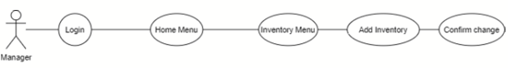

Participating actor: Manager

Entry condition:

• Manager has inventory not put into the database

• Manager is on the website

Exit condition:

• Manager receives confirmation of updated inventory

Event flow:

1. Manager selects inventory to be added to the database

2. Website sends request to the Server

3. Server confirms update.

4. Website displays confirmation to Manager

## 

## Use Case 6

## Name: Discard Inventory

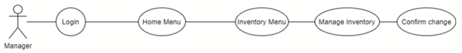

Participating actor: Manager

Entry condition:

• Manager has expired inventory to take out of the database.

• Manager is on the website

Exit condition:

• Manager receives confirmation of updated inventory

Event flow:

1. Manager selects inventory to be discarded and clicks a discard button.

2. Website sends request to the Server

3. Server confirms update.

4. Website displays confirmation to Manager

## 

## Use Case 7

## Name: Viewing and Printing Analytics

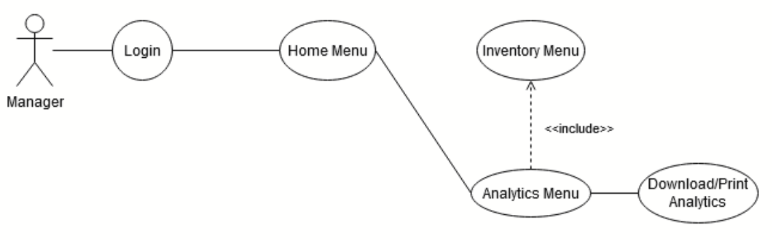

Participating actor: Manager

Entry condition:

• Manager has wants to see details about recent orders and inventory changes

• Manager is on the website

Exit condition:

• Manager prints views or downloads the report generated.

Event flow:

1. Manager selects the analysis menu

2. Website sends request to the Server

3. Server confirms update.

4. Website displays analysis and offers ways to download

## 

## Use Case 8

## Name: Managing User Accounts

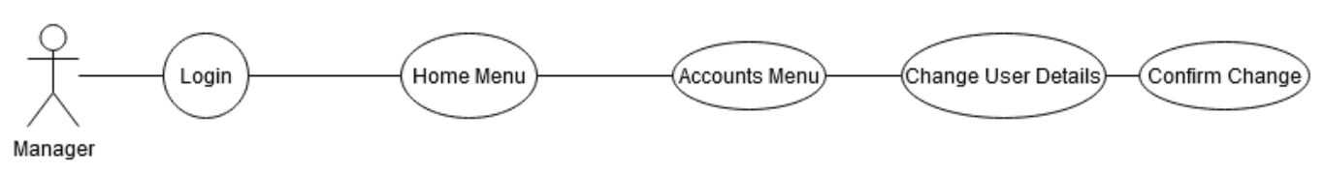

Participating actor: Manager

Entry condition:

• Manager wants to delete users or change user account types for employees or customers

• Manager is on the website

Exit condition:

• Manager receives confirmation of updated account and sends that details to that accounts

Event flow:

1. Manager selects accounts menu

2. Website sends request to the Server

3. Server confirms update.

4. Manager selects accounts to edit and changes information.

5. Manager selects confirm and server sends confirmation on screen and in email about change.